To avoid dirty read and unrepeatable read, use

Connection.Transaction_Repeatable_Read

JDBC-Java Database Connection- things needed: setAutoCommit(bool) (false for HW3), setTransactionIsolation, commit(), prepareCall(String), <- Callable Statement <- tied to queries <-stored procedures, Connection

RW conflict

Good relational database design:

1. Reduce redundancy
2. Query performance

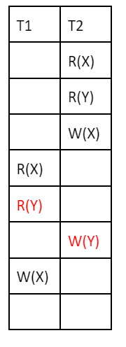

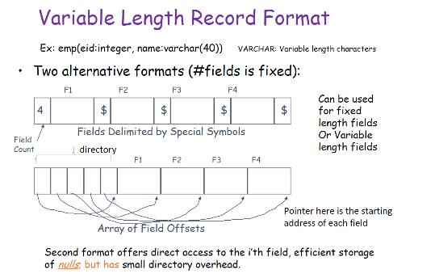

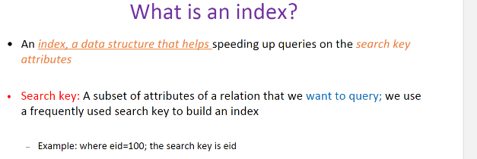

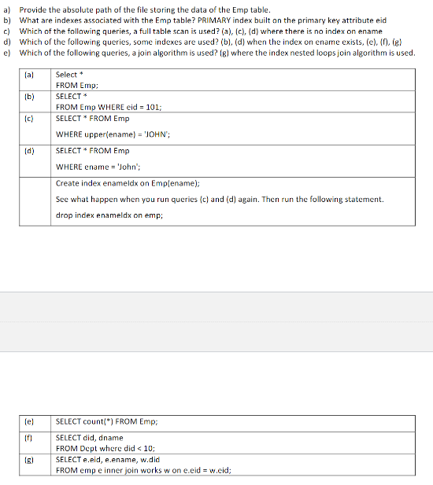

Benefits of DBMS: reduce dev time, Data independence, Efficient Access, Data integrity, Ease of data sharing/ security but cannot model all requirements